**USER MANUAL - SALES ANALYSIS PROGRAM**

This program has been designed to efficiently manage the current stock position and refills/restocks for the vending machines. The program identifies each machine with a distinct number and allows the user to add multiple slots within a single machine. Within every slot, there are varied products stored, each product marked with a distinct Product ID to effectively manage the accounting of stock and sales.

The vending machine presents the following options as the user menu, the description for each option is provided for your perusal.

***Menu Options:***

1 : Add/Edit Machine Profile: This option can be used to ‘Add/Edit’ both Machine profiles and slots or Products.

2 : Pre-view Sales: This option can be used to access the sales summary on a daily basis.

3: Process Daily Sales: This option can be used for reporting the sales summary to the operational team for allocating the refills as per the daily demand.

4: Product Daily Sales Analysis: This option can be accessed for getting a visual interpretation on the sales of all the products for a day.

Q : Quit: This option allows the user to quit the program.

***Note: The user is advised to undertake the options – Pre view sales, Process Daily sales and Product Daily Sales Analysis, before making any amendments to the machine profile and slots (i.e. Option 1). This will ensure that no past data is getting removed during the analysis.***

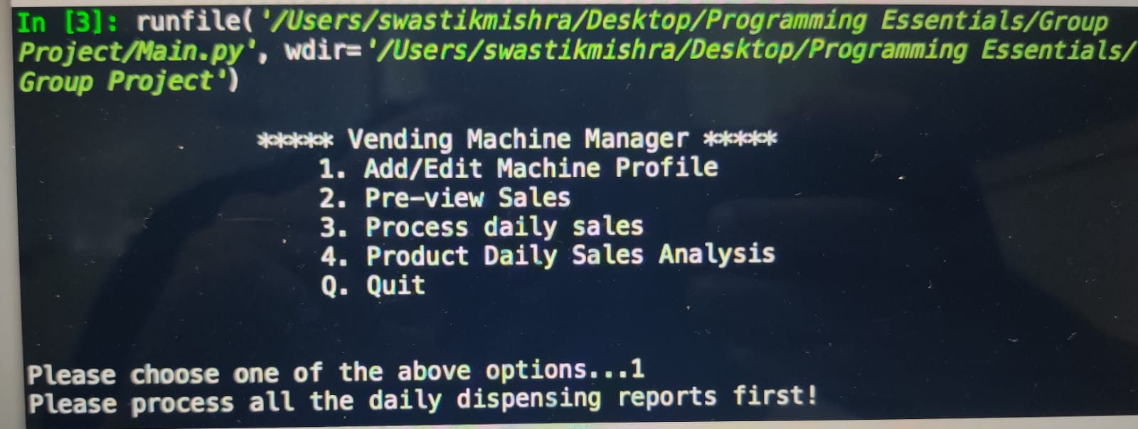

**Option 1: Add/Edit Machine Profile**

The ‘Add/Edit Machine Profile’ options allows the user to both Add new Machines (wherein new slots and products can also be added) and Edit the existing Machine profiles including the slots and products associated with the same. As an extension to this option, user is also allowed to remove the slots and products, additionally allowing them to remove the complete Machine profile as well.

1. Upon selection of Option 1, the user will be prompted to input the Machine ID, on which he wants to perform the above described function. The input shall look as given below.

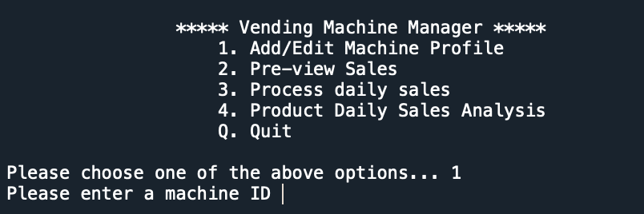

1. After providing the input the program will verify if the given Machine ID is given as an integer, if not the machine will throw an error and suggest the user to add an integer value to proceed. Post inputting the integer value, the program will search if the Machine ID is already loaded in the system, and if the case is true, the program will display the existing Slot IDs and Product IDs associated with the Machine ID entered.

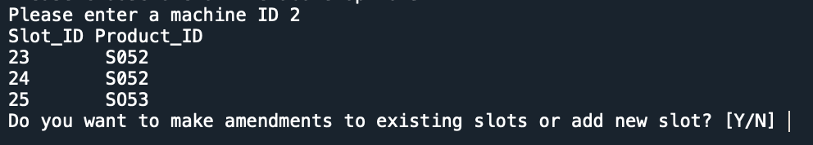

1. The user will then be prompted if they want to amend the existing slots and products in the same Machine ID. If the user replies “Y” in this space, he will be asked to enter the Slot ID and Product ID to the corresponding Machine ID. If the slot ID is existing in the system, product record associated with the slot in the system will be amended. On the other hand, if the slot doesn’t exist for that machine a new slot with the product will be created under the mentioned machine ID.

*Adding the slot and products:*

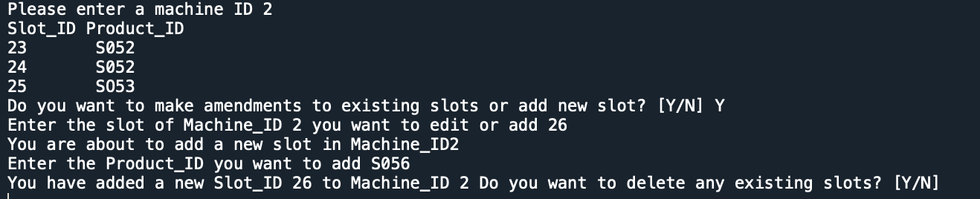

*Editing the slot and products:*

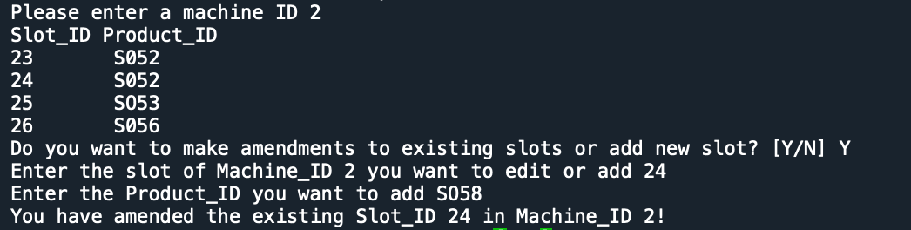

1. On the contrary, if the program finds that given Machine ID does not match with any in the system, it will add this as the new machine and a similar prompt for adding Slot IDs and Product IDs associated with a new Machine ID will be displayed. After providing all the information, the user will get the below notification:

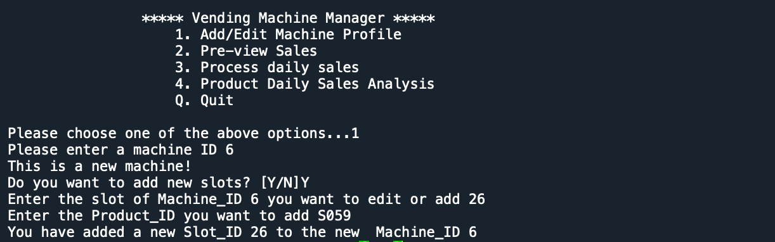

1. If the user chooses “N” when asked for add/edit, he will still be prompted if he wants remove any slots/machine profile, as explained in the next paragraph.

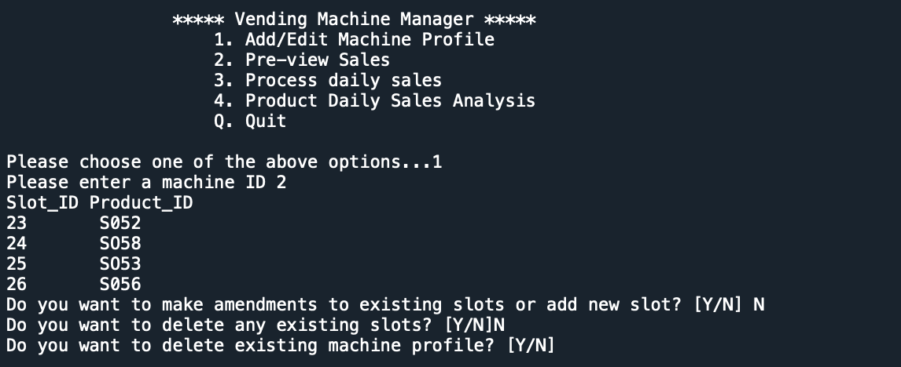

1. Further, the user will be asked if wants to remove any existing slots in the Machine, wherein they need to enter the Slot ID and the corresponding Machine ID and Product ID will also be removed.

Additionally, the user will also be given an option to delete the complete Machine profile if required. For this, user will be asked to enter the Machine ID, and the program will then again delete the whole Machine profile including the Slot IDs and Product IDs attached to that Machine. In both these cases, the user has to respond with a “Y” for the program to trigger the delete function and post the completion, the user will be displayed the following message:

*Removing Slots/Products:*

**

*Removing Machine Profiles:*



1. With the delete option, the user is provided an option to delete multiple Slots and Machines under one run. The program will ask the user on how many slots/machines they would want to delete as depicted below:

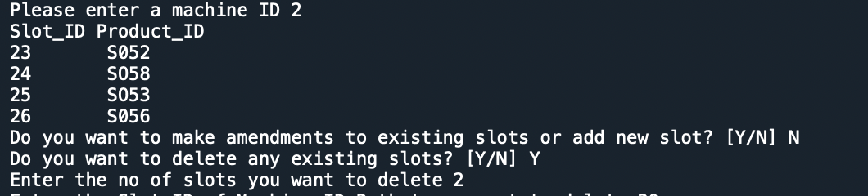

1. If the user responds with a “N” in both delete options, they will be taken back to the Main Menu option, from where they can continue accessing other options or can quit the program.

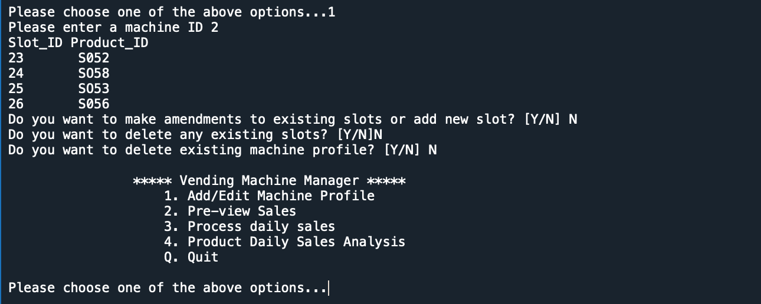

1. Furthermore, if in this section, the user enters any Slot/Product ID which is not existing in the system, an error will be displayed and the user will be asked to enter any existing Slot/Machine ID.

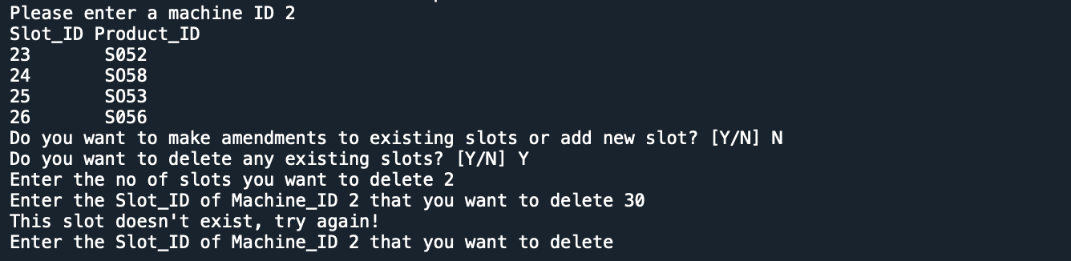

**Option 2: Pre-view Sales**

The ‘Pre-view Sales’ option indicates the quantity of each product dispensed on a daily basis, categorized by the Product ID, slots in which the product is in (Slot ID) and the machine ID. It retrieves the Slot ID and quantity from various dispensing reports, corresponding to the date keyed in, and provides a summarized table depicting the quantity of various products dispensed across all slots and machines on a particular day. The output of this option is shown in the image below:

The detailed instructions required for this output are as follows. Please be mindful of the format of the various inputs as an error will be encountered if the inputs are not keyed in the right format.

1. Upon choosing option 2, the user will be prompted to key in the date for which they expect the summary of quantity dispensed. An image of the prompt and sample input required to enter is presented below:

* *Prompt:*



* *Sample Input:*



1. Ensure to key in the date in the format ‘YYYY-MM-DD’, where all the values are integers. Please be careful and enter the date in the correct format, else an error will be encountered:



1. Once the date has been keyed in correctly, the program will investigate the dispensing reports to retrieve the necessary data. Please take note that if the date does not match any of the dispensing reports, an error message will pop up that states ‘Files not Found’. This is an example of the error message:

1. If the user already processed the dispensing reports pertaining to a particular date (via Option 3) , they will not be able to process the same date again. Any attempts to enter the same date more than once will trigger an error and they will encounter the message, ‘Files of the day has been processed’.



1. Upon successful entry of dates and retrieval of data, the user will be presented with an output that indicates the Machine ID, Product ID, Quantity and Slot ID as seen below:

**Option 3: Process Daily Sales**

The ‘Process Daily Sales’ option collects all the information of the products dispensed across all slots and machines on a particular day and shows it in the csv file “summarySales.csv”. The information of each record is categorized as Date, Machine ID, Product ID, Slots ID and quantity of dispensing products. Once the user enters the date he or she wants to know about, the according information will be extracted from the dispensing files of the date in the “pending folder”, and added to the csv file. The adding of information will not damage any existing information inside the csv file. However, the new data will replace the existing data of the same date in csv file.

The dispensing files retrieved will be moved to the “complete folder”, which is automatically created by the system. The output of this option is shown in the image below when entering date 2022-07-28:

The following are the thorough instructions needed for this output. Please pay attention to the format of the different inputs since if they are not entered correctly, an error will occur.

1. You will be asked to enter the date for which you would like to receive the report of products dispensed when you select option 3. The prompt and an example of the data you to enter are shown in the following image:

* *Prompt:*

* *Sample Input:*



1. Ensure to key in the date in the format ‘YYYY-MM-DD’, where the values for date are integers separated by “-”. Please be careful and enter the date in the correct format, else an error will be encountered:



1. Once the date has been entered in correct format, the application will go into the “pending” folder's dispensing reports to get the relevant information. Please be aware that a 'Files not Found' error message will appear if the date does not match any of the dispensing reports. Below is an illustration of an error message:

1. The user won't be able to process the same date again if you have already processed the dispensing reports for that date. If they try to enter the same date more than once, an error will occur and the notice "Files of the day has been processed" will appear.

Unlike the “Files not found”, this means the dispensing reports for this date have been moved to the “complete folder” and the records of this date have been added to the csv file.



1. Upon successful entry of dates and retrieval of data, the user will receive following results.

* The daily sales information of the input date will be presented in the “summarySales.csv”, while dumping any existing information of the same date.

* A new folder “complete” will be created in the current folder to store the dispensing report retrieved from the “pending” folder.

1. If the user enters another date, the daily sales data will continually be appended to the “summarySales.csv”, and the according dispensing report will be moved to the current “complete” folder from “pending” folder.

For example, when an input of the date 2022-07-29 is given:

The “summarySales.csv” and “complete” folder will update:

**Option 4: Product Daily Sales Analysis**

The ‘Product Daily Sales Analysis’ shows the sales quantity of a particular product in a particular month/year. Upon the selection of option 4, the user will be prompted to key in 3 different details for the generation of the sales analysis:

1. The year of sales
2. The month of sales
3. Product ID

Keying Year of Sales

* The user will be prompted to key in the year of sales they are looking at. Please key in the year in ‘YYYY’ format (e.g. 2022).



 (*with input*)

* If the year that has been keyed in does not match the sales database, an error message would surface and the program would ask the user to input the year again. An example of the error message is shown below:



Keying Month of Sales

* After the year has been keyed in, the user will be prompted to key in the month of sales they are looking at. Please key in the digit for the month you are looking at (e.g. 7 for July).



(*with input*)

* If the digit that has been keyed in is not a valid month, an error message would surface and the program would ask the user to input the month again. An example of the error message is shown below:



Product ID

* After the year and month have been keyed in, the user will be prompted to key in the product ID they are looking at. Please key in the full Product ID you are looking at (e.g. SXXX).



(*with input*)

* If the Product ID that has been keyed in is not valid, an error message would surface and the program would ask the user to input the Product ID again. An example of the error message is shown below:



After all three details have been keyed in, the program will print the product daily sales analysis, for the perusal. An example of the sales analysis that would be shown can be found below:

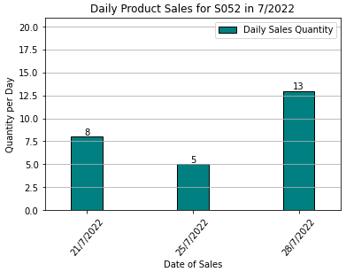

The chart would be title based on the product ID and month/year of sales that has been asked for. In the above case, the title of the chart is ‘Daily Product Sales for *S052* in *7/2022*’. The graph would display the daily product sales in order of the date of sales (x-axis). The total count of sales is also shown at the end of the bar for ease of reference.

In the event that there is no sales record for the Product ID, month and year, the program would notify with a message as shown below:



After printing the daily product sales, the program would return to the main menu to ask for the next line of action.